**Configuring and setup Raspbery pi temperature sensor**

**By Paul Richards**

[**paulware@hotmail.com**](mailto:paulware@hotmail.com)

1. Create a free [gmail.com](http://www.gmail.com) email account if you don’t have one already.
2. Insert SD card containing operating system and software provided by Paul into Raspberry pi
3. On the pc go to control panel, network, network adapter
4. Modify properties lan adapter settings for Internet Protocol Version 4 (TCP/IPv4) 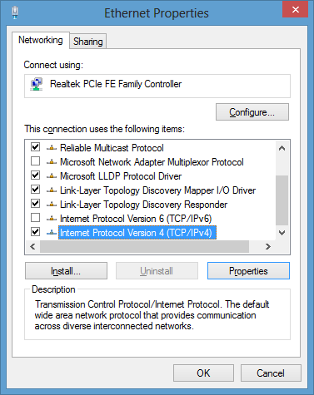
5. Set lan adapter settings so that you can communication with Raspberry Pi  
   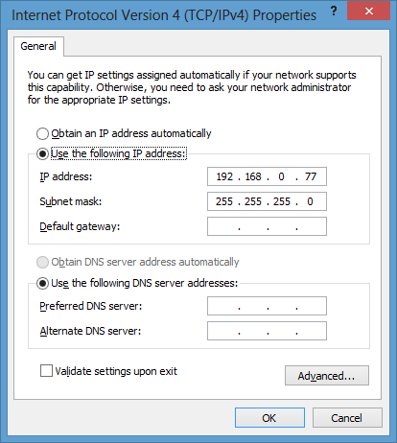
6. Connect a lan cable from raspberry pi to pc lan port (raspberry pi will start at 192.168.0.9)
7. Power up the raspberry pi
8. Wait 4 minutes for the raspberry pi to boot up.
9. On the pc a browser navigate to <http://192.168.0.9> you will see this page from the pi:  
     
   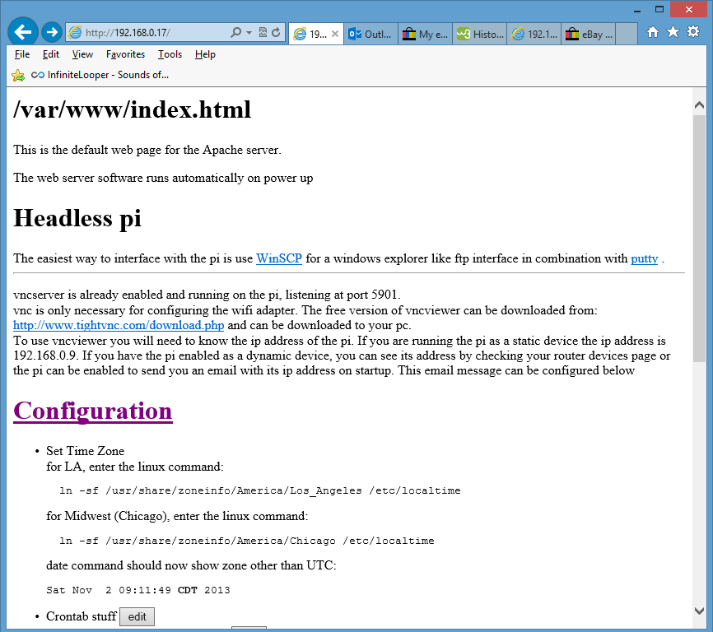
10. Click on [Configuration](http://192.168.0.9/cgi-bin/editConfiguration.py) hyperlink  
    You will see this page: 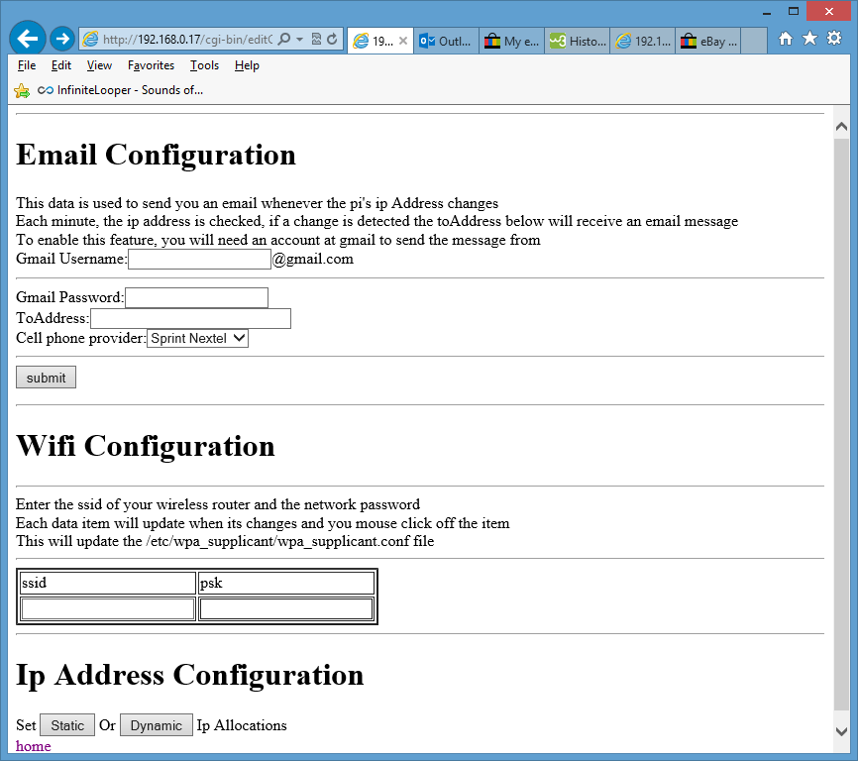
11. Enter the gmail account that you created and enter its password  
    Then enter the ToAddress where you want emails sent when water is detected. Select your cell phone provider and press submit.
12. On the same page, enter the ssid of your wireless network and its password. You need to click the mouse off the input to have the value changed.
13. Return to the home <http://192.168.0.9> page
14. Scroll down to Products and select sump pump hyperlink
15. You will see this page, Select Configure:  
    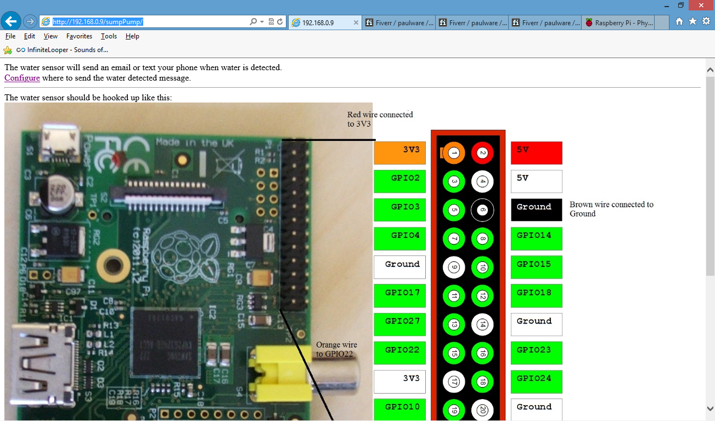
16. You will see this page:  
    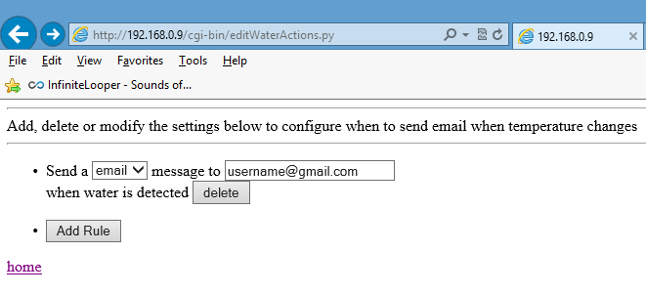
17. Select email or text and fill in the username or text phone number
18. Return to the main <http://192.168.0.9> [Configuration](http://192.168.0.9/cgi-bin/editConfiguration.py) page  
    Select the “Dynamic” button where the line says: “Set Static or Dynamic Ip Allocations”
19. Disconnect power to the raspberry pi
20. Connect the water sensor to the raspberry pi:
    1. Red wire to 3V3 power
    2. Brown wire to ground
    3. Orange wire to gpio22

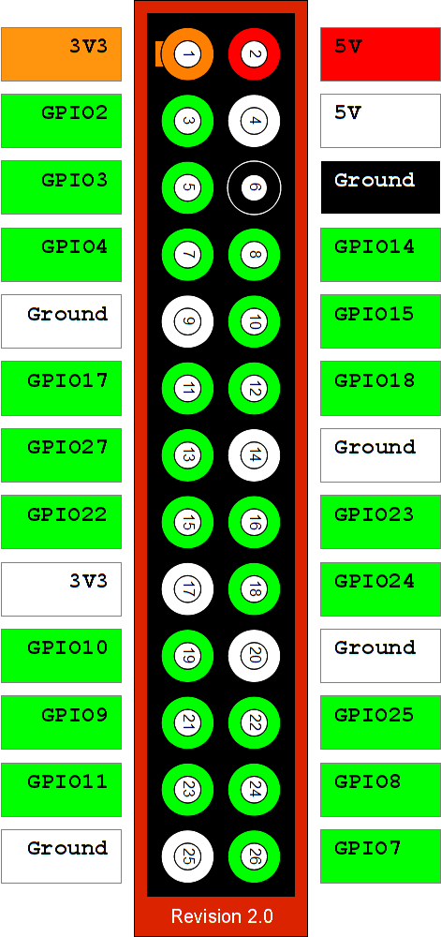

1. Connect your wifi dongle into the usb port or connect the raspberry pi to your router
2. Place the raspberry pi and sensor where it can detect water.
3. Reconnect the power to the raspberry pi.
4. The router will now assign a new ip address to your raspberry pi. The raspberry pi will now send you and an email whenever it boots up and also once a day at 5 AM (raspberry pi time). The pi will also send emails to your designated email account or text messages to your phone when water is detected.

If anything is not working or you get stuck, send me your question at [paulware@hotmail.com](mailto:paulware@hotmail.com)

All my products have full technical support

Thanks!

Paul